CATCHMENT 2030 INSTRUCTIONS

9.00am Welcome

9.15am Set the Scene (Video)

Catchment Simulation Briefing

The year is 2030. The place is County Catchment in the Eastern Region – see map.
The catchment is currently faced with a severe erosion problem – one of the worst in the world. The erosion has worsened with increases in the severity and frequency of storms. The local community is small and remote. In the most recent 2028 storm, parts of the catchment community were cut off from the region’s main urban centre of Easternville for more than six months. The cost to maintain infrastructure is challenging at the best of times for this community. What can be done to help County Catchment? When and by whom?

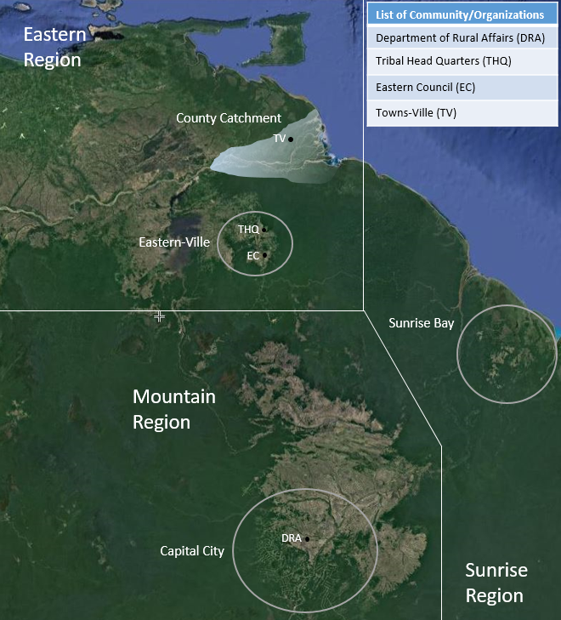
Each team plays the role of an individual in an organisation or within a group of individuals/organisations aiming to REINVIGORATE THE CATCHMENT (calendar year played out over 90 minutes). This includes a range of individuals and organisations who have interests and/or responsibilities for the environmental, socioeconomic and/or tribal outputs in the catchment – see ‘Who’s Who’ chart.

The groups of organisations include:
- Government (central and local) | - Tribal | - Industry
- Funders (investors/philanthropic) | - Community | - Research

9.30am Read your character profile (5 mins)
Get to know the other characters in your group (5 mins)
Read/discuss in your group other characters in the simulation (5 mins)

9.45am GROUP PLANNING - Using the form provided discuss and choose:
- YOUR CATCHMENT GOALS (10 mins)
- YOUR 3 POINT STRATEGY to achieve your goals (10 mins)
- Your Priority Targets – the other organisations/people in Catchment 2030 you believe are most important to help achieve your goals. (10 mins)
- Working morning tea (10am)
- SELECT YOUR REPRESENTIVE – WHO WILL REPORT BACK

10.15am ITERATIVE MEETINGS AND NEGOTIATION
- Catchment 2030 is based on a cascade of meetings between individuals and groups trying to explore working together to achieve outcomes
- A mistake is to assume you know what other groups actually want
- We recommend getting to talk with others as fast as possible at the beginning in order to adjust your strategy based on what you find out they actually want
- If no one seems interested in you, then go and connect with them
- Each meeting can involve more than two individuals or groups as long as all groups agree.
A suggested approach to follow:
- FIRST MEETING – find out the key goals of other groups
- SECOND MEETING – make INITIAL SUGGESTIONS/OFFERS to them
- THIRD+ MEETING(S) – getting CONTRACTS – action agreements /contracts with them signified by a ‘HONOURABLE HANDSHAKE’

The groups with budgets or investor funds must have made agreements to have spent all their budget by 11.15AM

11.15am Groups’ Feedback on What Happened
- Their goals and strategy
- What agreements/deals were made
- WHAT DID WE LEARN FROM THIS EXERCISE? Where to next?

12.30pm Close
WHO’S WHO AT CATCHMENT 2030

ORGANISATION OR GROUP REPRESENTED | WHO’S HERE
Big City University (BCU)  Major university whose staff have an interest in the erosion processes in the catchment. | Senior Lecturer
Bio Tairawhiti (BT)  Locally-based biotech start-up. | General Manager
Carbon Enterprise Ltd. (CEL)  Carbon services firm that helps landowners develop and certify their operations under the national Carbon Trading Program (CTP). CEL also brokers the sale of certified carbon credits to high carbon-emitting companies. | CEO
Community  County Catchment community members. | - Landowner  - 2 Absentee Landowners  - Farmer  - Organic Farmer  - Resident  - Former Resident  - Youth
Department of Environment and Climate Change (DECC)  Central government department active on environment and climate change issues nationally and internationally. | Minister for Climate Change
Department of Nature Conservation (DNC)  Central government agency responsible for protecting, conserving, and growing the country’s natural and historic heritage. | Manager – Easternville Regional Office
Department of Rural Affairs (DRA)  Central government department active on matters related to primary industries and rural revitalisation. | - Senior Advisor – Farming  - Senior Advisor – Forestry  - Director – Indigenous Partnerships  - Regional Programme Manager  - Eastern Region Local Staff
Department of Tribal Affairs (DTA)  Central government department active on matters related to indigenous development. | Minister
Eastern Ecotourism (EE)  Locally-based tourism business that runs guided experiences on the land and sea. | CEO
Eastern Farming (EL)  Tribal farm management company based in the County catchment that manages TROTT’s farm business. | General Manager
Eastern Forestry Ltd. (EFL)  Tribal forest management company based in the County catchment that establishes and manages forestry ventures, including the forestry interests of the Te Tairawhiti tribe. | General Manager
Eastern Regional Council (ERC)  Government authority responsible for the administration of Eastern municipality and Eastern Region. | - CEO  - Councillor – Townsville Ward  - Regional Economic Development Manager  - Staff – Economic Development Department  - Staff – Environment, Policy, and Practice Department
Eastern Roads Initiative (ERI)  Partnership between Eastern Regional Council (ERC) and the National Transport Authority (NTA) to manage Eastern Region’s state highways and local roads. | General Manager
Environmental Research (ER)  National research institute focused on environmental sustainability and care. | Researcher
Farmer Browns (FB)  Global farming company operating a large sheep and cattle farm in the County catchment. | - General Manager – Country Operations  - Farm Manager – County Catchment
Farmers Federation (FF)  Member-based organisation which advocates for farm and rural issues nationally and regionally. | - National President  - Eastern Region Regional Chair
Forest and Tree Foundation (FTF)  One of the leading independent forest conservation organisations in the country, working to protect, enhance, and restore indigenous forests. | Executive
Forest Enquiry (FE)  National research institute that looks to get the most value out of wood. | Researcher
Honi Collaborative (HC)  Collective of indigenous Te Tairawhiti landowners (including land trusts and incorporations) working toward greater involvement in the growing Eastern Region mānuka honey industry. | General Manager
Indigenous Trustee Corporation (ITC)  ITC proposes and manages indigenous land developments across the country. | - Executive
Philanthropy  Well-resourced philanthropists with a particular interest in combatting the catchment’s pressing social and environmental issues. | - Independent Philanthropist (social enterprise focus)  - Independent Philanthropist (environmental focus)  - Independent Philanthropist (forest focus)
Te Rūnanga o Te Tairawhiti (TROTT)  Official tribal organisation representing the interests and aspirations of the whānau (families) and hapū (sub tribes) of the Te Tairawhiti people. | - Chief Executive  - 5 Trustees  - Risk Manager  - Strategy and Planning Manager
Te Rūnanga o Te Tairawhiti (TROTT) Charitable Trust  TROTT’s charitable arm, tasked with sustaining and advancing Te Tairawhiti’s cultural development through the distribution of TROTT resources. | Chairperson – Charitable Trust
Te Rūnanga o Te Tairwahiti (TROTT) Commercial Holdings  TROTT subsidiary tasked with the development and oversight of TROTT’s commercial assets. | Chairperson – Commercial Holdings
Thrive Ltd. (TL)  Community-focused social enterprise providing business and leadership resources for entrepreneurs from the country’s underserved communities. | - Manager – External Relationships  - Community Liaison
WaterCare Research (WCR)  Independent research institute focused on freshwater, biosecurity, and aquaculture. | Researcher
Whole Country Initiative (WCI)  A national, non-partisan think tank that has funding to conduct research in the catchment. | Senior Researcher

SIMULATION MATERIALS

Name of your group is: ___________________________________________________________

Your Group Plan for 2030
- What are your catchment goals?

a____________________________________________________________________________

b___________________________________________________________________________

c____________________________________________________________________________

2. What are your 3 strategies for success to achieve your catchment goals?

a____________________________________________________________________________

b___________________________________________________________________________

c____________________________________________________________________________

3. Which other groups/people do you most need to work with to achieve your goals?

a____________________________________________________________________________

b___________________________________________________________________________

c____________________________________________________________________________

Your Group Results from the Catchment Simulation
What Deals/Agreements did you pull off?

Deals | With Who?

C. Your Group Learning from the Catchment Simulation?
What are the four key things you learned from the Catchment 2030 Simulation and what do they mean in terms of a real catchment situation?

1_____________________________________________________________________________

2_____________________________________________________________________________

3_____________________________________________________________________________

4_____________________________________________________________________________

D. Some Final Feedback from the Simulation

- After participating in the Catchment 2030 Simulation, has it had any impact on your thinking about governance and management? If yes, what? If no, why not?

- Do you think that the Catchment 2030 Simulation is relevant for other situations? How?

- What specific ideas, tools or approaches from Catchment 2030 could you apply to other situations in which you are involved?

- What did you think of the Catchment 2030 Simulation overall? Do you have any suggestions for the organisers?

