Tool 1. Monitoring and Evaluation – Tracking progress and change

This tool comprises 5 steps as follows:
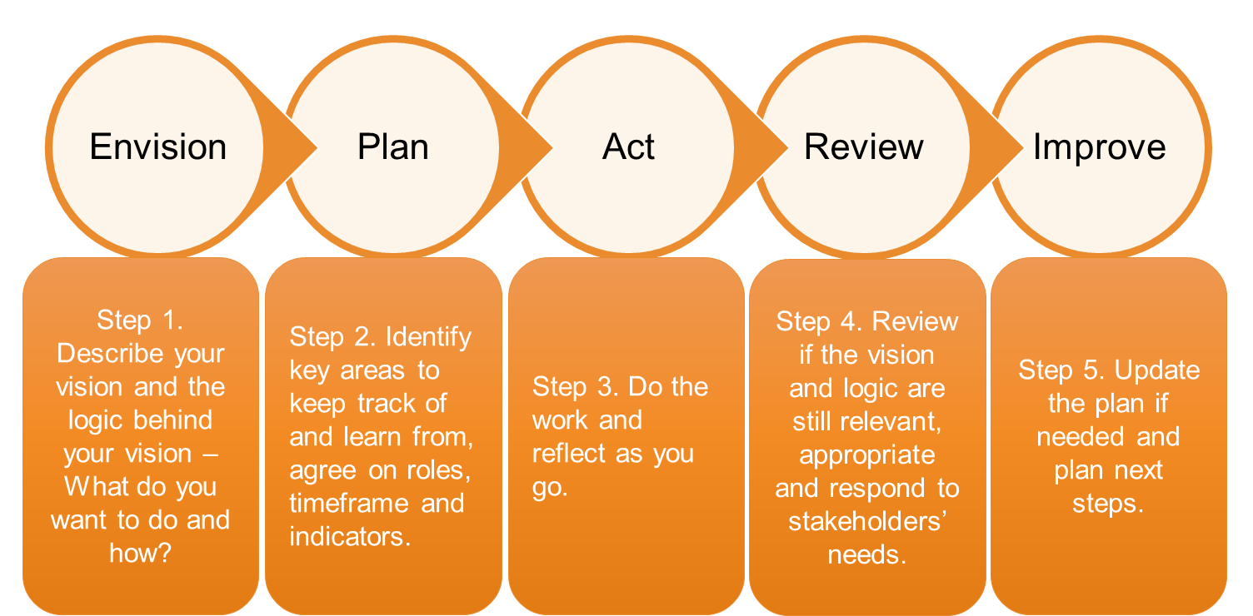

Answer the questions in the next pages to build a simple yet useful monitoring and evaluation (M&E) plan to track progress.

You can get back to this M&E plan and update when needed.

In the Appendix you will find a fillable ‘Vision map’ that you can use to start jotting down ideas about your plan or simply write your answers in the following pages.

Step 1. Envision. Describe your vision and the logic behind your vision – What do you want to do and how?
Questions | Your answers
LONG TERM IMPACTS: VISION OR ASPIRATION:
- What is your long term vision or aspiration for the future?
- What impact do you want to make on the world, your community, your country, etc.?
Tip: Keep it high and aspirational
LONG TERM OUTCOMES:
- What has decreased, increased or improved in the long term?

MEDIUM TERM OUTCOMES
- What has decreased, increased or improved in the medium term?

SHORT TERM OUTCOMES
- What has decreased, increased or improved in the short term?

ISSUES: PROBLEMS OR OPPORTUNITIES
- What are the current issues, problems or opportunities that your will tackle?

RESOURCES
- What do you need to make the activities happen?
- For example, what people capability and skills do you need? What financial resources would you need and for how long?

ACTIVITIES
- What are you going to do? When? With whom?
- For example, hui, workshops, field visits, experiments, interviews
TANGIBLE RESULTS
- After you completed your activities, what have you produced?

ASSUMPTIONS
- What are your assumptions to achieve your outcomes? For example:
  - Are your stakeholders well informed and involved? Are they on board?
  - If not, what can you do to involve them?
RISKS
- What are some risks of doing or not doing the activities or achieving results?
- What can prevent you from achieving results? For example:
  - Do you depend on legislation to be approved?
  - Are there any resources (financial, people, time) that could be a problem?

Step 2. Plan. Identify key areas to keep track and to learn from, agree on roles, timeframes and indicators – What, who, how, when?

Questions | Your answers
KEEPING TRACK OF OUTCOMES
- Who is in charge of keeping track of outcomes?
- When will you meet to keep track of outcomes? E.g. at annual, quarterly, or monthly meetings or specific project monitoring meeting
- What indicators will you use?
  - Quantitative indicators, e.g. financial resources investment, hectares of land restored, number of trees planted, water quality index, catchment maps, statistics on population, unemployment, income, etc.
  - Qualitative indicators, e.g. group perception on how well a plan is accepted by the community, cultural health index, etc.
- What tools you will use to keep track of outcomes? e.g. annual ‘reflection’ sessions, reports, minutes, action points, interviews with stakeholders or informed persons, community meetings.

KEEPING TRACK OF ACTIVITIES
- Who is in charge of keeping track and how often?
- What tools you will use to keep track of activities? (e.g. surveys, reports, interviews, etc.)
- What areas are you going to keep track of? For example:
  - How effective the activity was in achieving its objectives?
  - How appropriate the activity was for the people involved?
  - What can be improved?

KEEPING TRACK OF RESOURCES
- Who is in charge of keeping track and how often?
- What tools you will use to keep track of activities? (e.g. financial statements, people’s availability, social networks, etc.)
- How are you going to keep track? For example:
  - Do we have enough resources to deliver?
  - If not, what resources are needed and how and when they will be available?
  - If they are not available, what is plan B?
Step 3. Act. Do the work and reflect as you go
  - Do the work
  - Document lessons as you go using the ‘ORID’ guiding questions:
    - Objective: What happened?
    - Reflective: How did you feel about the issue/experience?
    - Insights: What does it mean? What are the key messages?
    - Decision: So what action do we/can we take as a result?
  - Minutes of meetings can also be a learning tool if they include: planned steps, actions, observed impacts
  - Most importantly, ‘Reflection time’ needs to be built into the calendar.

Step 4. Review. Review if the vision and logic still relevant, appropriate and responds to stakeholder’s needs
  - Does the vision still make sense or do you need to update or modify?
  - What have you learned?
  - What needs to change?

Step 5. Improve. Update the plan if needed & plan next steps.
  - You might find that you need to change your plans or experiment with new ways of doing things if what you’re doing isn’t giving you the results you want.
  - Adjust your plan based on your review in Step 4.
  - Agree on next steps.
Risks
Appendix. Vision map (logic framework)
M&E
M&E
M&E
Assumptions
M&E
M&E
M&E
Long term impacts (Vision or aspirations)
Issues: Problems or opportunities
Activities
Tangible results
Resources
Long term outcomes
Medium term outcomes
Short term outcomes
LONG TERM OUTCOMES
RESOURCES
TANGIBLE RESULTS
ACTIVITIES
ISSUES: PROBLEMS OR OPPORTUNITIES
RISKS

